#24

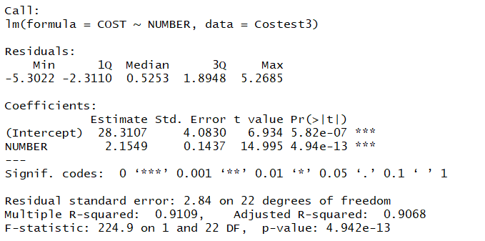

a)

Use 95% level of significance, we assume that the hypotheses is

H0: beta_1 = 0

Vs

Ha: beta_1 <> 0

t_value = 14.995 = 15



We know the critical value for a 5% of significance is 2.074.

Since 15 > 2.074, we reject H0, therefore, we conclude that the linear relationship is significant.

the conclusion should be "There is sufficient evidence at 5% level of significance to suggest that β_1 is significantly different from 0. "

b)

(I am not sure the meaning of this question. I mean, I could just know the two elements have an obvious positive linear relation)

So, they should pay attention on the linear relationship between them, and do a Linear programming to find the point that they could make the highest profit.

Should say "There is sufficient evidence to conclude"(-0pt)Should mention "a significant linear relationship"

c)

R^2 = 0.911, this means the cost of the production run and number of items produced during that run have a positive relationship. 91.1% of variation in y could be explained by the regression.

d)

when x_m = 33, y_m = 2.15 * 33 + 28.31 = 99.26

S_m = S_e * sqrt((1/n) + ((x_m – mean_x)/((n -1) * (S_x)^2))

mean_x = 28.125



(n-1)(S_x)^2 = sum ((x_i – mean_x)^2)) = 16.98 * 24 = 407.52



S_e = 2.84

S_m = 2.84* sqrt((1/24) + (33-28.125)^2/407.52) = 0.898

For 95% confidence interval, t_critical = 2.074

Thus, the 95% confidence interval estimate of the average cost with 33 items run is,

(y_m – t_a/2,n-2 *S_m, y_m + t_a/2,n-2 *S_m)

= [99.26 – (2.074)(0.898), 99.26 + (2.074)(0.898)]

= (99.26 - 1.86, 99.26 + 1.86)

= (97.4, 101.12)

So, the area is (97.4, 101.12)

e)

Similar progress like c)

x_ m = 40, y_m = 114.31

mean_x = 28.125

(n-1)(S_x)^2 = sum ((x_i – mean_x)^2)) = 16.98 * 24 = 407.52

S_e = 2.84

S_m = 2.84* sqrt((1/24) + (40-28.125)^2/407.52) = 0.756

For 95% confidence interval, t_critical = 2.074

Thus, the 95% confidence interval estimate of the average cost with 40 items run is,

(y_m – t_a/2,n-2 *S_m, y_m + t_a/2,n-2 *S_m)

= (112.74, 115.88)

So, the area is (112.74, 115.88)

Not right answer. You can use predict function in R to compute the interval for you

#25

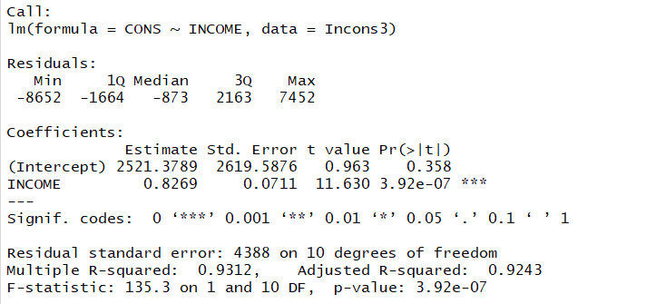

same as 24)(a)(b) (d)(-1pt) the interval should be ($55,024.8 $65,783.29)

a)

Use 95% level of significance, we assume that the hypotheses is

H0: beta_1 = 0

Vs

Ha: beta_1 <> 0

t_value = 11.63



t_critical here is 2.23

Since 11.63 > 2.23, we reject H0, therefore, we conclude that the linear relationship is significant.

b)

So, we could speculate that a family earn more, they spend more.

c)

R^2 = 0.9312, this means the income of a family and the consumption of a family have a positive relationship. 93.12% of variation in y could be explained by the regression.

d)

Similar progress with #24.

when x_m = 70,000, y_m = 60404.3789

S_m = S_e * sqrt((1/n) + ((x_m – mean_x)/((n -1) * (S_x)^2))

mean_x = 3225



(n-1)(S_x)^2 = sum ((x_i – mean_x)^2)) = var_25 *2



I don’t know , but my computer gave me this



I cannot do this, so I left blanks for that.

S_e = 0.4388

S_m = 0.4388 * sqrt((1/12) + (70000 - 3225)^2/((n-1)(S_x)^2)) =

For 90% confidence interval, t_critical = 1.81

Thus, the 90% confidence interval estimate of the average cost with 33 items run is,

(y_m – t_a/2,n-2 *S_m, y_m + t_a/2,n-2 *S_m)

=

e)

Similar with the last one.

when x_m = 85,000, y_m =72807.8789

S_m = S_e * sqrt((1/n) + ((x_m – mean_x)/((n -1) * (S_x)^2))

mean_x = 3225

(n-1)(S_x)^2 = sum ((x_i – mean_x)^2)) = var_25 *2

Same problem.

S_e = 0.4388

S_m = 0.4388 * sqrt((1/12) + (85000 - 3225)^2/((n-1)(S_x)^2)) =

For 90% confidence interval, t_critical = 1.81

Thus, the 90% confidence interval estimate of the average cost with 33 items run is,

(y_m – t_a/2,n-2 *S_m, y_m + t_a/2,n-2 *S_m)

=

the interval should be (62096.56, 83518.39)

#26

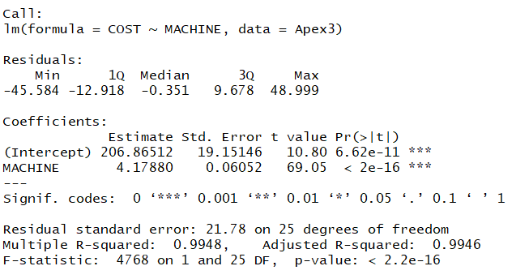

a)

Use 95% level of significance, we assume that the hypotheses is

H0: beta_1 = 0

Vs

Ha: beta_1 <> 0

t_value = 69.05



Since 69.05>2.06, we reject H0, therefore, we conclude that the linear relationship is significant.

b)

So, they should pay attention on the linear relationship between them, and do a Linear programming to find the point that they could minimize the cost.

c)

R^2 = 0.9948, this means the income of a family and the consumption of a family have a positive relationship. 99.48% of variation in y could be explained by the regression.

d)

Similar with #24

when x_m = 254, y_m = 1268.28032

S_m = S_e * sqrt((1/n) + ((x_m – mean_x)/((n -1) * (S_x)^2))

mean_x = 308.8



(n-1)(S_x)^2 = sum ((x_i – mean_x)^2)) = 4982.72*27 = 134533.44



S_e = 21.78

S_m = 21.78* sqrt((1/27) + (254 - 308.8)^2/134533.44) = 21.78 * 0.243637 = 5.306



For 99% confidence interval, t_critical = 2.787



Thus, the 99% confidence interval estimate of the average cost with 254 items run is,

(y_m – t_a/2,n-2 *S_m, y_m + t_a/2,n-2 *S_m)

= [1268.28032 – (2.787)( 5.306), 1268.28032 + (2.787)( 5.306)]

= (1253.49, 1283.069)

So, the area is (1253.49, 1283.069)

e)

When the total time is 254, the average time is 254/27 = 9.4 hours.

Similar progress.

when x_m = 9.4, y_m = 246.14

S_m = S_e * sqrt((1/n) + ((x_m – mean_x)/((n -1) * (S_x)^2))

mean_x = 308.8



(n-1)(S_x)^2 = sum ((x_i – mean_x)^2)) = 4982.72*27 = 134533.44



S_e = 21.78

S_m = 21.78* sqrt((1/27) + (9.4 - 308.8)^2/134533.44) = 21.78 * 0.8386537 = 18.26



For 99% confidence interval, t_critical = 2.787



Thus, the 99% confidence interval estimate of the average cost with 254 items run is,

(y_m – t_a/2,n-2 *S_m, y_m + t_a/2,n-2 *S_m)

= [246.14 – (2.787)( 18.26), 246.14 + (2.787)( 18.26)]

= (195.25, 297.03)

So, the area is (195.25, 297.03)

same as 24)(a) (b) (e)(-1pt) the interval should be (1205.8, 1330.8)